# VISVESVARAYA TECHNOLOGICAL UNIVERSITY

**“Jnana Sangama”, Machhe, Belagavi, Karnataka-590018**



An Internship Report

*On*

**“STUDY ON DIFFERENT SECTIONS OF CESCOM”**

***Submitted in partial fulfillment of the requirements for the award of the degree of***

# Bachelor of Engineering

In

# Electrical & Electronics Engineering

***Submitted By***

# RAKSHITHA G (4GW19EE030)

***at***

# CESCOM, MYSORE

Internal Guide **Smitha S K Asst. Professor**

## EEE Department

**Under the guidance of**

External Guide **Lokesh L General Manager CESC, Mysore**



# DEPARTMENT OF ELECTRICAL & ELECTRONICS ENGINEERING

**(B.E (E&E) Program Accredited by NBA, New Delhi, Validity from 01.06.2021 to 30.06.2024)**

# GSSS INSTITUTE OF ENGINEERING & TECHNOLOGY FOR WOMEN

**(Affiliated to VTU, Belagavi, Approved by AICTE, New Delhi & Govt. of Karnataka)**

**K.R.S ROAD, METAGALLI, MYSURU-570016, KARNATAKA**

## Accredited with Grade “A” by NAAC 2023

Geetha Shishu Shikshana Sangha (R)

# GSSS INSTITUTE OF ENGINEERING & TECHNOLOGY FOR WOMEN

## K.R.S Road, Mysuru-570016, Karnataka

(Affiliated to VTU, Belagavi, Approved by AICTE -New Delhi & Govt. of Karnataka)

**Accredited with Grade ‘A’ by NAAC**

## DEPARTMENT OF ELECTRICAL AND ELECTROINICS ENGINEERING

**(B.E (E&E) program Accredited by NBA, New Delhi, validity from 01.06.2021 to 30.06.2024)**



# CERTIFICATE

Certified that the 7th Semester Internship titled **“STUDY ON DIFFERENT SECTIONS OF CESCOM’’** is a bonafide work carried out by **RAKSHITHA G (4GW19EE030)** in partial fulfillment for the award of degree of bachelor of engineering in **Department of Electrical & Electronics Engineering** of the Visvesvaraya Technological University, Belagavi, during the year 2022-2023. The internship report has been approved as it satisfies the academic requirements with respect to the Internship work prescribed for Bachelor of Engineering Degree.

|  |  |  |
| --- | --- | --- |
|  | **Smitha S K** | **Dr. G Sreeramulu Mahesh** |
| Asst. Professor | Professor and Head |
| Department of EEE | Department of EEE |
| **Examiner 1** | **Examiner 2** |
| **Name: Signature** |  |  |

# ACKNOWLEDGEMENT

The joy and satisfaction that accompany the successful completion of any task would be incomplete without the mention of the people who made it possible.

First and foremost I offer my sincere phrases of thanks to **Smt**. **Vanaja B Pandit,** Hon. Secretary, GSSSIETW and the management of GSSSIETW, Mysuru for providing help and support to carry out the internship.

I would like to express my gratitude to our Principal**, Dr. Shivakumar M** for providing a congenial environment for engineering studies and also for having showed me the way to carry out the internship.

I consider it a privilege and honour to express my sincere thanks to **Dr. G Sreeramulu Mahesh** Professor and Head, Department of Electrical & Electronics Engineering for his support and invaluable guidance throughout the tenure of this project.

I would like to thank my External Guide **Lokesh L**, General Manager, CESC for his support, guidance, motivation, encouragement for the successful completion of this internship.

I would like to thank my Guide **Smitha S K** Assistant Professor, Department of Electrical & Electronics Engineering for her support, guidance, motivation, encouragement for the successful completion of this internship.

I intend to thank all the teaching and non-teaching staffs of my Department of Electrical & Electronics Engineering for their immense help and co-operation.

Finally I would like to express my gratitude to my parents and friends who always stood by

me.

Thank you.

**RAKSHITHA G**

**(4GW19EE030)**

# CONTENTS

|  |  |  |
| --- | --- | --- |
| **Sl. No.** | **Description** | **Page Number** |
| 1. | **Chapter 1: Company Profile** | 1 |
| 2. | **Chapter 2: Transformers**   * 1. : Introduction   2. : Types of Transformers 2.3: Distribution Transformer   3. : Manufacturing Process      1. : Core Construction      2. : Transformer Lamination      3. : Windings      4. : Core and Coil Assembly 2.4.5: Tanks   2.4.6: Processing of Core and Coil Assembly 2.4.7: Paint Finish Process  2.5: Transformer Testing 2.5.1: Open circuit Test 2.5.2: Short circuit Test  2.5.3: Transformer Ratio Test | 2 - 15 |
| 3. | **Chapter 3: Energy Meters**   * 1. : Introduction   2. : Types of Energy Meters      1. : Electromechanical Meters 3.2.2: Electronic Energy Meters 3.2.3: Smart Meters | 16 - 20 |

|  |  |  |
| --- | --- | --- |
| **Sl. No.** | **Description** | **Page Number** |
|  | * 1. : Energy Meter Testing Laboratory   2. : Calibration and Testing of different Meters |  |
| 4. | **Chapter 4: Different Sections**   * 1. : Customer Care Center 4.1.1: Complaint Section   2. : Billing Section   3. : Budget Allocation   4. : Vendor Approval Process   5. : Brief Study of CESC Mysore App | 20 - 21 |
| 5. | **Chapter 5: Cyber Security**   * 1. : Introduction   2. : Types of Cyber Crime   3. : Advantages of Cyber Security   4. : Safety Tips against Cyber Security 5.5: Material Management   5.6: SCADA | 22 - 23 |
| 6. | **Chapter 6: Conclusion** | 24 |
| 7. | **References** | 25 |

**LIST OF FIGURES**

|  |  |  |
| --- | --- | --- |
| **SI. NO** | **Figures** | **Page Number** |
| 1. | Fig 1: Company Profile | 1 |
| 2. | Fig 2.1: Transformer | 2 |
| 3. | Fig 2.3: Distribution transformer | 4 |
| 4. | Fig 2.4.1.1: Three limbs core Interleaved joints | 6 |
| 5. | Fig 2.4.1.2: Three limbs core Mitered joints | 6 |
| 6. | Fig 2.4.2: Transformer Lamination | 7 |
| 7. | Fig 2.4.3.1: LV Winding | 7 |
| 8. | Fig 2.4.3.2: HV Winding | 8 |
| 9. | Fig 2.4.4: Core assembly | 9 |
| 10. | Fig 2.4.5: Transformer tank | 9 |
| 11. | Fig 2.4.6: Oven heating | 10 |
| 12. | Fig 2.4.7: Painted Transformer | 11 |
| 13. | Fig 2.5.1: connection diagram for open circuit test | 13 |
| 14. | Fig 2.5.2: connection diagram for short circuit test | 14 |
| 15. | Fig 2.5.3: Transformer ratio test | 15 |
| 16. | Fig 3.1: Energy meter | 16 |
| 17. | Fig 3.2.1: Electromechanical meter | 17 |
| 18. | Fig 3.2.2: Electronic energy meter | 18 |
| 19. | Fig 3.2.3: Smart meter | 18 |
| 20. | Fig 3.3: Energy Meter Testing laboratory | 19 |
| 21. | Fig 5.6: SCADA | 23 |

**CHAPTER 1**

**COMPANY PROFILE**

Chamundeshwari Electricity Supply Corporation Ltd. (CESC, Mysore) is an electricity distribution company with its headquarters in Mysore. It was established in 2005 and is a subsidiary of the Karnataka Electricity Board (KEB).



## Fig 1: Company Profile

The five districts were distributed electricity by Karnataka Power Transmission Corporation (KPTCL) since its formation in 1999 to 2002. Mangalore Electricity Supply Company Limited (MESCOM) was one of four companies that was formed in 2002 from KPTCL, and distributed to the said districts before CESC was carved out of it in 2005 to meet the increasing demand in power. Kodagu was added to its jurisdiction in 2006.

CESC provides its services in 5 districts of Karnataka

* Mysore
* Chamarajanagar
* Mandya
* Hassan
* Kodagu

Dept. Of EEE, GSSSIETW, Mysuru Page | 1

**CHAPTER 2**

**TRANSFORMERS**

# INTRODUCTION

A transformer is a static device that transfers electrical energy from one circuit to another without any change in frequency but change in Voltage and current.

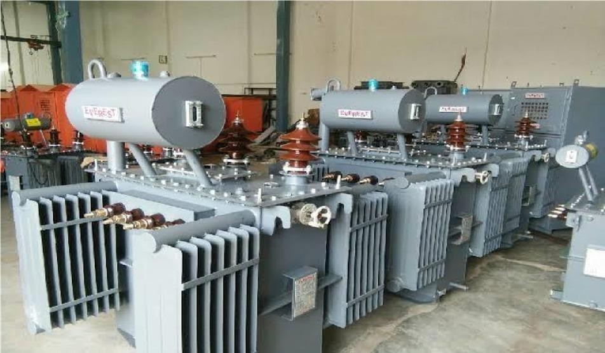

## Fig 2.1: Transformers

Working principle of transformer: The working principle of transformer is very simple. It depends upon Faraday’s law of electromagnetic induction. Actually mutual induction between two or more winding is responsible for transformation action in an electrical transformer.

Faraday’s laws of electromagnetic induction: According to these Faraday’s law “Rate of change of flux linkage with respect to time is directly proportional to the induction EMF in a conductor or coil”. Basic Theory of transformer Consider one winding which is supplied by an alternating electrical source. The alternating current through the winding produces a continually changing flux or alternating flux surrounds the windings. If any other winding is brought nearer to the previous one, obviously some portion of this flux will link with the second. As this flux is continually changing in its amplitude and direction, there must be a change in flux linkage in the second winding or coil. According to Faraday’s law of electromagnetic induction, there must be an EMF induced in second.

If the circuit of the latter winding is closed, there must be an electric current flows through it.

The winding which gives the desired output voltage due to mutual induction in the transformer, is commonly known as secondary winding of Transformer. Here in our example for secondary winding. The above mentioned form of transformer is theoretically possible but not practically, because in open air very tiny portion of the flux of the first winding will link with second so the electric current flows through the closed circuit of latter, will be so small that it may be difficult to measure. The rate of change of flux linkage depends upon the amount of linkage flux, with the second winding. So it desired to be linked almost all flux of primary winding, to the secondary winding. This is effectively and efficiently done by placing one low reluctance path common to both the winding. This low reluctance path is core of transformer, through which maximum number of flux produced by the primary is passed through and linked with the secondary winding. This is most basic theory of transformer.

# TYPES OF TRANSFORMERS:

A wide variety of transformer designs are used for different applications. Some important types are given as:

* Power transformer
* Distribution transformer
* Instrument transformers
* Auto-transformer
* Resonant transformer

# DISTRIBUTION TRANSFORMER

A distribution transformer is a static device constructed with two or more windings used to transfer alternating current electric power by electromagnetic induction from one circuit to another at the same frequency but with different values of voltage and current. A distribution transformer is the type of transformer that performs the last voltage transformation in a distribution grid. It converts the voltage used in the transmission lines to one suitable for household and commercial use, typically down to 240 volts. There are four types of distribution transformer connections available like star- star, delta-delta, star-delta, delta-star and Zig Zag/delta zigzag. Transformer which is used for the purpose of distribution of power. 11KV/433 V is the standard voltage rating. STANDARD KVA ratings are 25, 63, 100, 160, 200, 250, 315, 400, 500, 630, 750, 1000, 1250, 1500, 2000, 2500 KVA.

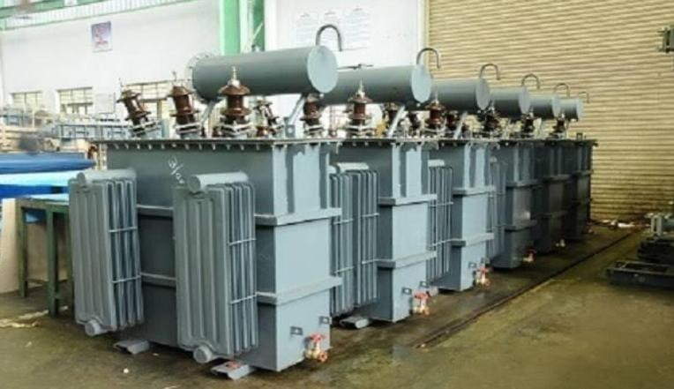.

**Fig 2.3: Distribution transformer**

# MANFACTURING PROCESS

## CORE CONSTRUCTION

Material for Transformer core the main problem with transformer core is, its hysteresis loss and eddy current loss in transformer. Hysteresis loss in transformer mainly depends upon its core materials. It is found that a small quantity of silicon alloyed with low carbon content steel produces, material for transformer core which has low hysteresis loss and high permeability.

As the increasing demand of power ratings, it is required to further reduce the core losses and for that another technique is employed on steel, which is known as cold rolling. This technique arranges the orientation of grain in ferromagnetic steel in the direction of rolling.

The core still which has under gone through the both silicon alloying and cold rolling treatment, is commonly known as CRGOS or cold rolled grain-oriented silicon steel. This material is now universally used for manufactured for transformer core. Although this material has low specific iron loss but still it has come disadvantages, like it is susceptible to increase loss due to flux flow in direction other than grain orientation and it also susceptible to impaired performance due to impact of bending, blanking the cutting CRGOS sheet. Both surfaces of the sheets are provided with an insulating of oxide coating.

During core manufacturing in factory some factors are taken into consideration,

1. High reliability
2. Reduction in iron loss in transformer and magnetizing current
3. Lowering material cost and labor cost
4. Abatement of noise levels

Quality checking is necessary at every step of manufacturing to ensure quality and Reliability. The sheet steel must be tested for ensuring the specific core loss or iron loss values. The lamination should be properly checked and inspected visually, rusty and bend lamination to be rejected.

For reducing the transformer noises the lamination should be tightly clamped together and punch holes should be avoided as far as possible to minimize cross flux iron losses. The air gap a the joint of limbs and yokes should be reduced as much as possible for allowing maximum smooth conducting paths for magnetizing current.

The cross-grain loss mainly occurs in the zones of corner jointing of limbs with Yokes and it can be controlled to some extend by applying special corner jointing techniques. There are normally two types of joints used in transformer core

* 1. Interleaved joints
  2. Mitered joints

1. **Interleaved joints:** Interleaved joint in transformer core is the simplest form of joints. This joint is shown in the figure. The flux leaves and enters at the joint in perpendicular to grain orientation. Hence cross grain losses is high in this type of joints. But considering the low manufacturing cost it is preferable to use in small rating transformer.
2. **Mitered joints:** Here the laminations are cut at 45˚. The limbs and yoke lamination edges are placed face to face at the mitred joints In transformer core. Here the flux enters and leaves the lamination gets smooth path in the direction of its flow. Hence cross grain loss is minimum here. However it involves extra minimization is of the main criteria of design of transformer core.

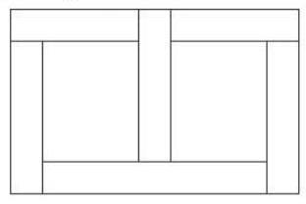

## Fig 2.4.1.1: Three limbs core Interleaved joints

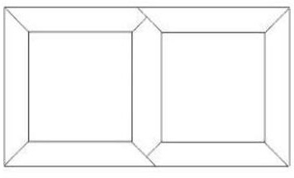

**Fig 2.4.1.2: Three limbs core Mitered joints**

## TRANSFORMER LAMINATION

CRGO Wound Core The manufacturing of strips wound cores is a specialized process, which requires a high degree of precision. These cores are manufactured from selected coils of CRGO electrical steel to yield closely controlled electro-magnetic characteristics and dimensional accuracy. The cores are stress-relief annealed to restore the magnetic properties. The cores are bonded where necessary, provided increased firmness. Transformer core laminations: The laminations are stacked in steps, resulting in a circular core shape which gives the windings optimum radial support, especially during short–circuit condition.

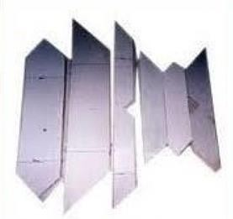

## Fig 2.4.2: Transformer Lamination

* + 1. **WINDINGS**

Winding are of circular design, with concentric coil placement. Both copper and aluminum conductor can be supplied depending upon customer requirements. The transformer will have low voltage (LV) winding and high voltage (HV) winding Wound over the limbs. The LV winding is placed near the core. There will be a gap Between LV and HV windings for oil circulation. The HV winding is placed away from the cylinder will depend upon the number of turns and area of cross section of Winding wire.

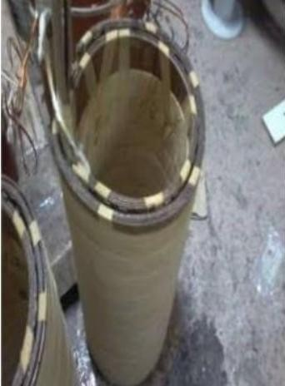

## Fig 2.4.3.1: LV Winding

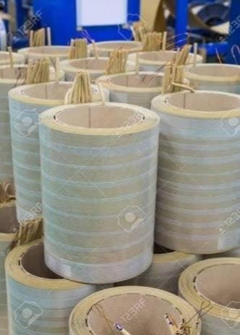

**Fig 2.4.3.2: HV Winding**

Precision slit, and edge conditioned aluminum strip is used in the low voltage section to eliminate hot spots and for improved short circuit Strength. Winding tension are carefully monitored and controlled throughout the winding process to ensure a strong, tight coil assembly. Thermally upgraded electrical insulation grade Kraft paper which has a diamond pattern heat set epoxy coating on both side of the paper, is used throughout the coil to maximize short circuit strength.

Copper placed between magnet wire used in the high –voltage section of the coils is Accurately Placed between cuffed edges of thermally set diamond paper insulation Hard pressboard cooling ducts allow for an even flow of oil throughout the coil for Cool efficient operation.

## CORE AND COIL ASSEMBLY

First, the individual windings are assembled one over the other to form the entire phase assembly the radial gaps between the windings are subdivided by means of solid transformer Board barrier.

The complete phase assemblies are then carefully lowered over the Separate core legs and solidly packed towards the core to assure optimal short circuit Capability. The top core yoke is then repacked and the complete core coil assembly is Clamp

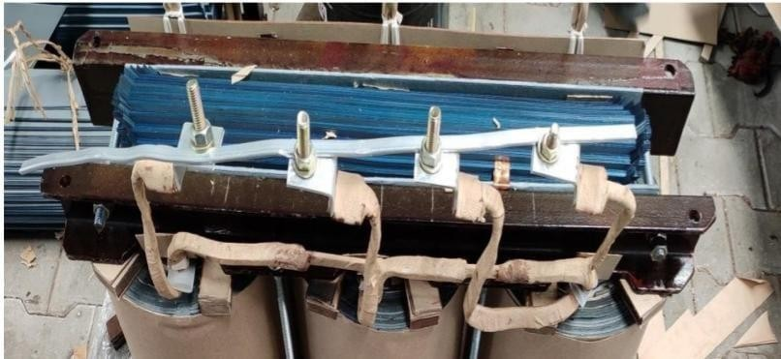

## Fig 2.4.4: Core assembly

* + 1. **TANKS**

All tanks are designed to withstand full vacuum and are manufactured from high quality steel plate.

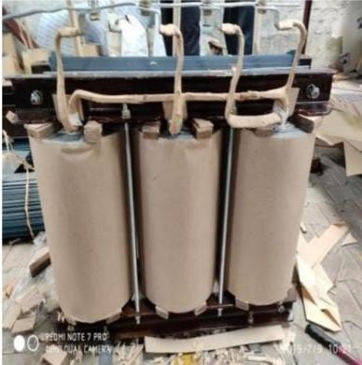

## Fig 2.4.5: Transformer tank

Facilities for lifting, jacking and pulling are provided on each transformer tank. Hand holes and manholes are placed for easy to interior components such as de energized tap switches and bushing connections. Tank bases are either flat or have structural members which allow skidding of the transformer in two directions, as required by the specification. The transformer can be designed with a welded or a bolted cover or as a bell type tank.

## PROCESSING OF CORE AND COIL ASSEMBLY

After the core and coil is combined, it is secured by special frames and banding. Leads and accessories are added, and preliminary test will be conducted to check insulation and isolation of the coils, then the finished assembly is baked to remove any moisture that may have been absorbed through the manufacturing process. The completed unit is retained in the tank by a three –point mounting system for superior strength. While the cores, coils and the core/coil assemblies are being processed, the tanks are being manufactured. Each tank is carefully tested to ensure leak free construction.

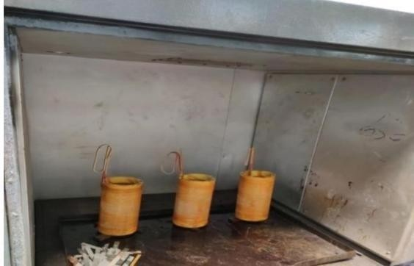

## Fig 2.4.6: Oven heating

Core coil assembly after drying out for 48 hours at 75 to 100o C in oven they are removed and inserted in to the tank after making the required connection to LV and HV terminals through high voltage bushings insulators. High voltage bushing are made of a strong wet process porcelain. The low voltage Bushing utilize a polymer housing. Terminals are plated for compatibility with copper and aluminum leads.

Core /core assembly is mated to a tank which has been prepped with ground lugs, and decals. Each transformer is then individually vacuumed (to complete the drying process) and filled with de- gassed high dielectric strength oil. The transformer remains under vacuum while the unit is filled with oil so as to ensure that all of the air and moisture are removed. Upon complete interior assembly, the cover –retaining band provides even gasket Compression plus conforms to ANSI requirements for a venting cover design. Core coil assembly moved to oven to remove moisture.

## PAINT FINISH PROCESS

The power partners factory utilizes a paint finish process called “2CEC” a trademark for a two-coat cathodic electro deposition paint process. This new advanced coating technique maintains the structural integrity of transformer that are subjected to the long –term corrosive environments of coastal areas and industrial contaminants. 8.2 Paint process cathodic electro deposition of paint occurs when direct current is applied to positively charged resin micelles dispersed in water. The resin micelles migrate toward the cathode (transformer tank) and are deposited in a process known as electrophoresis. As the process continues, the thickness limit. The most accessible areas resistance increases, and the film reaches a thickness limit. The most accessible areas are coated first, but as the resistance increases, less accessible areas coat, producing a highly uniformed film build.

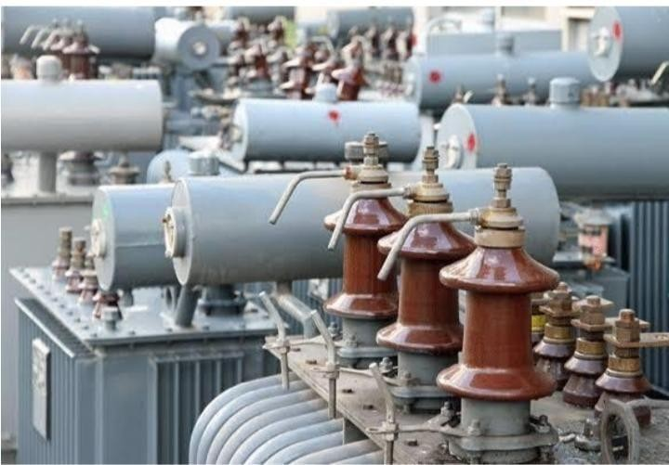

**Fig 2.4.7: Painted Transformer**

# TRANSFORMER TESTING

Each transformer must pass a complete series of electrical and mechanical tests that conform to the ANSI and IEEE standards. These tests include applied potential, full wave impulse, polarity, turns ratio, induced voltage, exciting current, core loss, winding loss, leak test, pressure withstand, and the primary and secondary winding resistance. Tests normally performed are:

1. Short circuit test
2. Open circuit test
3. Sumpner’s test
4. Polarity test

Upon successful completion of the rigid testing process, the unit is given a final inspection and the finishing touches are added to the unit. The final assembly processes include the attachment of the customer specified arresters and other protective equipment. These two tests are performed on a transformer to determine

* + Equivalent circuit of transformer
  + Voltage regulation of transformer
  + Efficiency of transformer

The power required for these open circuit test and short circuit test on transformer is equal to the power loss occurring in the transformer.

## OPEN CIRCUIT TEST ON TRANSFORMER

The connection diagram for open circuit test on transformer is shown in the figure. A voltmeter, wattmeter, and an ammeter are connected in VL side of the transformer as shown. The voltage at rated frequency is applied to that LV side with the help of a variac of variable ratio auto transformer. The HV side of the transformer is kept open. Now with help of variac applied voltage is slowly increase until the voltmeter gives reading equal to the rated voltage of the LV side. After reaching at rated LV side voltage, all three instruments.

The ammeter reading gives the no load current le. As no load current le is quite small Compared to rated current of the transformer, the voltage drops due to this electric Current then can be taken as negligible. Since, voltmeter reading V1 can be considered equal to secondary induced voltage of the transformer. The input power during test is indicated by watt-meter reading. As the transformer is open circuited, there is no output hence the input power here consists of core losses in transformer and copper loss in transformer during no load condition.

But as said earlier, the no load current in the transformer is quite small compared to full load current so copper loss due to the small noload current can be neglected. Hence the wattmeter reading can be taken as equal to core losses in transformer.

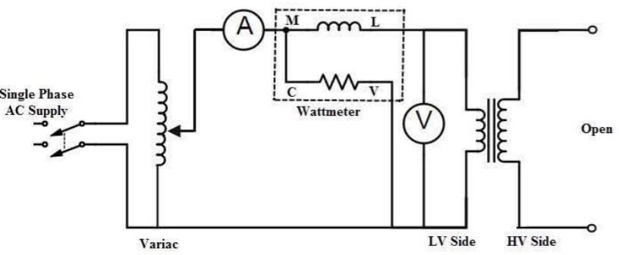

## Fig 2.5.1: connection diagram for short circuit test

* + 1. **SHORT CIRCUIT TEST ON TRANSFORMER**

The connection diagram for short circuit test on transformer is shown in the figure. A voltmeter, wattmeter, and an ammeter are connected in HV side of the transformer as shown. The voltage at rated frequency is applied to that HV side with the help of a variac of variable ratio auto transformer.

The LV side of the transformer is short circuited. Now with help of variac applied voltage is slowly increase until the ammeter gives reading equal to the rated current of the HV side. After reaching at rated current of HV side, all three instruments reading are recorded. The ammeter reading gives the primary equivalent of full load current IL.

As the voltage, applied for full load current in short circuit test on transformer, is quite small compared to rated primary voltage of the transformer, the core losses in transformer can be taken as negligible here.

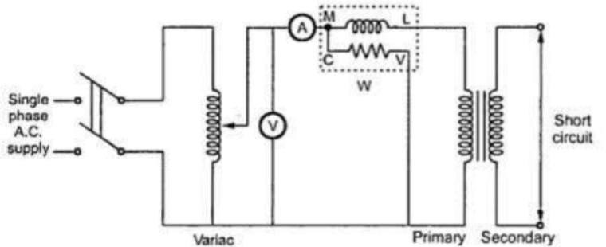

## Fig 2.5.2: connection diagram for short circuit test

* + 1. **TRANSFORMER RATIO TEST**

The performance of a transformer largely depends upon perfection of specific turns or voltage ratio of transformer. So transformer ratio test is an essential type test of transformer. The voltage should be applied only in the high voltage winding in order to avoid unsafe voltage. Ratio test of transformer and check of phase displacement actually the no load voltage ratio of transformer is equal to the turn ratio. So ratio test of transformer.

Procedure of transformer ratio test :

* + - 1. First, the tap changer of transformer is kept in the lowest position and LV terminals are kept open.
      2. Then apply 3 phase 415 V supply on HV terminals. Measure the voltages applied on each phase (phase-phase) on HV and induced voltage at LV terminals simultaneously.
      3. After measuring the voltage at HV and LV terminals, the tap changer of transformer should be raised by one position and repeat test.
      4. Repeat the same for each of the tap position separately.

The above transformer ratio test can also be performed by portable transformer turns ratio (TTR) meter. They have an inbuilt power supply, with the voltages commonly used being very low, such as 8-10 V and 50Hz.

The HV and LV windings of one phase of a transformer are connected to the instrument, and the internal bridge elements are variety to produce a null indication on the detector. A voltage is applied to the one of the windings by means of a bridge circuit and the ratio of induced voltage is measured at the bridge.

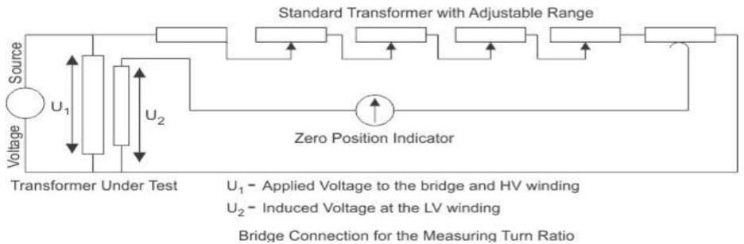

**Fig 2.5.3: Transformer ratio test**

**CHAPTER 3**

**ENERGY METERS**

# INTRODUCTION

The meter which is used for measuring the energy utilises by the [electric load](https://circuitglobe.com/electrical-load.html) is known as the energy meter. The energy is the total power consumed and utilised by the load at a particular interval of time. Energy Meters are electrical instruments that measures the amount of electrical energy used by the consumers. The basic unit of power is watts and it is measured using a wattmeter. If an individual use one kilowatt in one hour duration, one unit of energy gets consumed. Hence energy meters measure the rapid voltage and currents, calculate their product and give instantaneous power over a time interval, which gives the energy utilized over that time period.

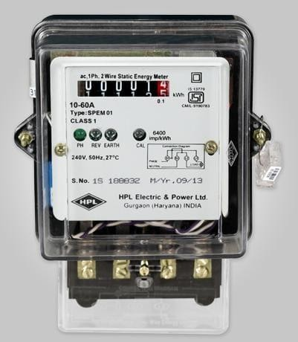

## Fig 3.1: Energy meter

The energy meter has four main parts. They are the driving system, moving system, braking system, registering system.

The electromagnet is the main component of the driving system. It is the temporary magnet which is excited by the current flow through their coil. The core of the electromagnet is made up of silicon steel lamination.

The driving system has two electromagnets. The upper one is called the shunt electromagnet, and the lower one is called series electromagnet.

The moving system is the aluminium disc mounted on the shaft of the alloy. The disc is placed in the air gap of the two electromagnets. The eddy current is induced in the disc because of the change of the magnetic field. This eddy current is cut by the [magnetic flux](https://circuitglobe.com/what-is-magnetic-flux.html). The interaction of the flux and the disc induces the deflecting torque.

The permanent magnet is used for reducing the rotation of the aluminium disc. The aluminium disc induces the eddy current because of their rotation. The eddy current cut the magnetic flux of the permanent magnet and hence produces the braking torque. The main function of the registration or counting mechanism is to record the number of rotations of the aluminium disc.

# TYPES OF ENERGY METERS

* + 1. **ELECTROMECHANICAL METER**

It measures electricity consumption using a combination of electrical and mechanical parts. It consists of rotating aluminium disc mounted on a spindle between two electro magnets. Speed of rotation of disc is proportional to the power and this power is integrated by the use of counter mechanism. The major problem with these meters is that they can be easily prone to tempering, leading to a requirement of an electrical energy monitoring system. These are very commonly used in domestic and industrial applications.

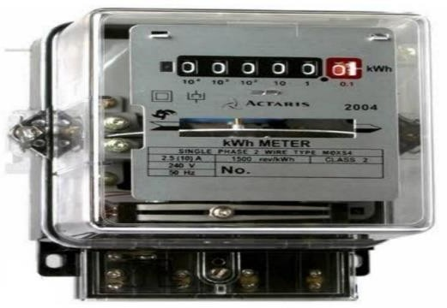

**Fig 3.2.1: Electromechanical meter**

* + 1. **ELECTRONIC ENERGY METER**

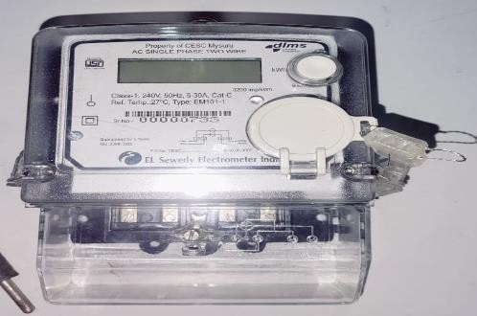

**Fig 3.2.2: Electronic energy meter**

Electronic energy meter or electricity meter is an instrument used to calculate the total energy consumed by a commercial office, home or electronic device.

Electronic Energy Meter is based on Digital Micro technology (DMT) and uses no moving parts. Hence the electronic energy meter is known as Static Energy meter.

* + 1. **SMART METER**

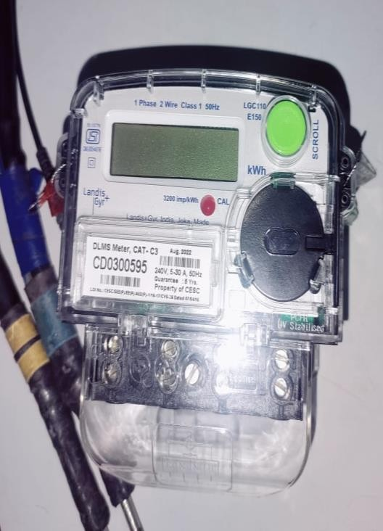

**Fig 3.2.3: Smart meter**

Smart meter is an electronic device that records information such as consumption of electric energy, voltage level, current and power factor. It is an advanced metering technology involving placing intelligent meters to read, process and feedback the data to customers. It measures energy consumption, remotely switches the supply to customers and remotely controls the maximum electricity consumption. Smart metering system uses the advanced metering infrastructure system technology for better performance

# ENERGY METER TESTING LABORATORY

* An energy meter is an instrument used to measure electrical energy.
* It keeps record of the total energy consumed in a circuit during a particular period.
* In every test it ensures the use of best equipment for testing electric meters.
* Devices and equipment that can test multiple energy-meters at the same time were shown in the laboratory.
* Different sections were allocated for LT meter testing and HT meter testing.

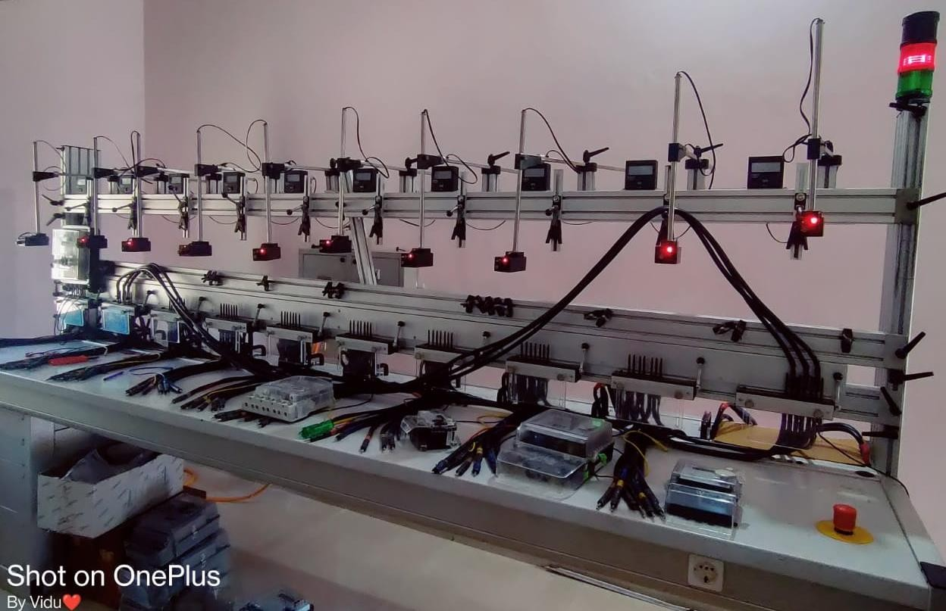

**Fig 3.3: Energy Meter Testing laboratory**

# CALIBRATION AND TESTING OF DIFFERENT METERS

* Energy meter calibration is a process required to determine and reduce the error when the energy is measured.
* The errors in the energy meter can be caused by different sources like voltage transformers, current transformers errors due to phase angle, crystal oscillators, etc.
* Energy meters have specified characteristic constants, which give information about the number of revolutions of the disc and the measured energy in joules.
* The performance tests of an energy meter as per its calibrated values are checked under various tests for different aspects like its mechanical aspects, electrical circuiting and climatic conditions.

**CHAPTER 4**

**DIFFERENT SECTIONS**

# CUSTOMER CARE CENTER / CALL CENTER SECTION

* Takes calls from customers & addressing any concerns.
* 24 hrs. call centre is available.
* To docket and share updates regarding breakdown to the consumer and internal stakeholders.

## COMPLAINT SECTION

* Complaint section in CESC monitors the and attends the complaints lodged through various medium like phone calls, website portal, SMS, etc.
* Official website https://cescmysore.karnataka.gov.in/english
* These complaints maybe from the consumers regarding power outages or any other related issues faced by them affecting their daily life functioning.

# BILLING SECTION

* To keep track on sales transaction that have taken place
* It keeps record of all the consumers’ monthly consumption to bill the expenses and charge the customers.

# BUDGET ALLOCATION

* The process of budgeting for capital expenditures (capex) is essential for CESC in order to operate. It provides necessary services to consumers from each section as per the requirement.
* It also helps the organization to sustain and fulfil its duty.

# VENDOR APPROVAL PROCESS

* The vendor base of CESC Limited is a potential network of mainly direct manufacturers, ancillaries, dealers and OEMs on a Pan India basis.
* They form the main backbone of our Supply Chain.
* Vendors are technically and commercially approved before vendor registration.
* Competitive Bidding among the registered approved vendors is in place to procure material of any value.
* Every year a Vendor Meet is organized by Materials Division to acknowledge the efforts made by the performing vendors.

# BRIEF STUDY OF CESC MYSORE APP

It is a fully featured App for Chamundeshwari Electricity Supply Limited consumers. Main features of this application are,

* Register complaints about the services which will be monitored by complaint section.
* Get the latest bill information updated by billing section.
* Get the power outage and other notifications.
* You can easily locate the CESC offices nearer to you.

**CHAPTER 5**

**CYBER SECURITY**

# CYBER SECURITY

Cyber security is the protection of internet-connected systems, including hardware, software and data, from cyber-attacks. We can categorize cybercrime in two ways

* + 1. The computer as a target: Using a computer to attack other computers

e.g. Hacking, virus/worms attacks, DoS attack etc.

* + 1. The computer as a weapon: Using a computer to commit real world crime

e.g. Credit card fraud etc.

# TYPES OF CYBER CRIME

* Hacking
* Phishing
* Denial of Service
* Spam Email
* Spyware, Adware
* Malware (Trojan, Virus, Worms etc.)
* Ransomware

# ADVANTAGES OF CYBER SECURITY

* It will defend us from hacks and virus. It helps us to browse the safe website.
* Internet security process all the incoming and outgoing data on our computer.
* The cyber security will defend us from critical attacks.
* The application of cyber security used in our PC needs update every week.
* The security developers will update their database every week once. Hence the new virus is also detected.

# SAFETY TIPS AGAINST CYBER CRIME

* Use Antivirus software.
* Insert Firewalls
* Uninstall unnecessary software.
* Maintain backup.
* Check security settings.
* Never give your name or address to strangers.
* Learn more about the internet privacy.

# Material Management (to plan, organize & control steps within its business process)

The main works of material management section are:

* To provide uninterrupted supply chain amidst dynamism of internal and external factors, maximize demand fulfilment with cost reduction, transparency and integrity throughout the procurement process.
* They also encourage competition by providing opportunity to qualified bidders.
* They also ensure a seamless integration of the procurement process. Strengthening the potential vendor base and consolidating vendor relationships are ensured by this section.
* They also try to maintain proper co-ordination with all stakeholders.

# SCADA (Supervisory Control and Data Acquisition)

* SCADA (supervisory control and data acquisition) is a category of software applications for controlling industrial processes, which is the gathering of data in real time from remote locations in order to control equipment and conditions.
* 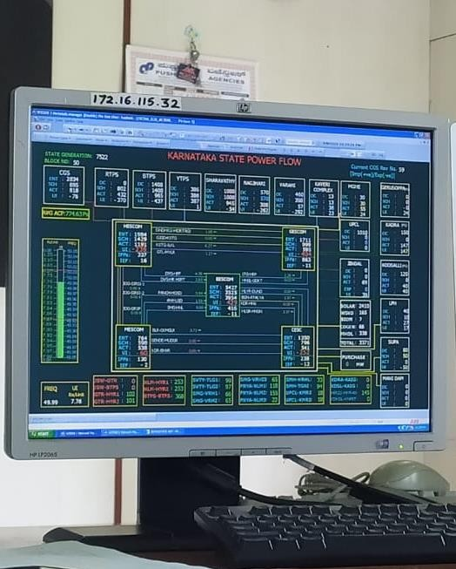The SCADA system developed provides fault isolation operation, monitoring and controlling functions for the operators and data collection for future analysis.

**Fig 5.6: SCADA**

**CHAPTER 6**

**CONCLUSION**

* Engineering students will have to serve in the public and private sector industries since workshop-based training and teaching in classroom has its own limitations, internship plays a major role.
* The lack of exposure to real life functioning of industrial organization internship plays a major role in student employment as it is very beneficial in bridging the gap between our theoretical knowledge and the practical scenario.
* This internship report brief about the different sections of CESCOM.A brief description about the transformers, energy metres & cyber security. All the concepts studied during the course have been reported.
* Power system controls (Transformers manufacture) visit helped in understanding of various process involved in Transformer.

# REFERENCES

1. htpp//google.com
2. htpp//en.Wikipedia.org
3. Electrical power transformers by James H. Harlow
4. htpp//www.sreesai enterprises
5. Mack, James E.; Shoemaker, Thomas. "Chapter 15 - Distribution Transformers"
6. Flanagan, William M ,Handbook of Transformer Design & Applications (2nd ed.) McGraw- Hill. ISBN 978-0-07-021291-6. pp. 2-1, 2-2